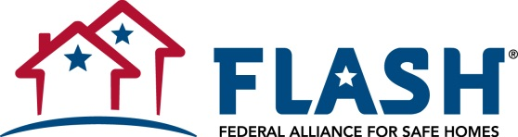
NEWS RELEASE

Contact: Tami Fillyaw
Tami@flash.org
850.385.7233 ext. 112 850.264.7327 (mobile)

For Immediate Release

Federal Alliance for Safe Homes (FLASH)® Warns Delay of Building Codes Puts North Carolina Residents at Risk
Delayed Building Codes Can Undermine Community Safety

(Tallahassee, FL) – The Federal Alliance for Safe Homes (FLASH) today issued the following statement regarding a proposal slated for a vote by the North Carolina Building Code Council on Tuesday, December 10. The proposed measure would move North Carolina from a three-year to a six-year adoption cycle for commercial and many other building safety codes. Earlier this year, the North Carolina Legislature approved a measure setting back residential building code adoption to a six-year cycle. Governor Pat McCrory signed the bill into law the same month.
According to FLASH President and CEO Leslie Chapman-Henderson,

“We are deeply concerned that North Carolina public safety policy is moving in the wrong direction. By stalling implementation of life-saving and cost-saving measures in up-to-date building codes, North Carolina communities will almost certainly fall behind and miss out on the latest advantages in building safety.

“Research and real-world disaster experience have proven again and again that modern, model building codes save lives, offer families financial security, improve recovery time, protect economic interests and underpin overall community resilience. Safety delayed is safety denied, and all citizens deserve these most basic, minimum protections.”

About FLASH
Federal Alliance for Safe Homes (FLASH)®, a 501(c)3 nonprofit organization, is the country's leading consumer advocate for strengthening homes and safeguarding families from natural and manmade disasters. FLASH collaborates with more than 100 innovative and diverse partners that share its vision of making America a more disaster‐resistant nation including: BASF, Federal Emergency Management Agency, Florida Division of Emergency Management, The Home Depot®, International Code Council, Kohler® Generators, National Weather Service, Portland Cement Association, RenaissanceRe, Simpson Strong-Tie®, State Farm™, USAA® and WeatherPredict Consulting Inc. In 2008, FLASH opened the interactive weather experience StormStruck: A Tale of Two Homes® in Lake Buena Vista, FL. Learn more about FLASH and gain access to its free consumer resources by visiting www.flash.org or calling (877) 221- SAFE (7233).

